Website Report
- Overview
- Title: The Official Chelsea Outlet Store.
- Name: Daniela Jaggan
- Description: This website is an e-commerce website based on displaying and selling jerseys of Chelsea FC players from earlier years, which would not be posted/found on the Original Chelsea FC Megastore website. The website allows you to view, remove and add items to your cart as well as which ever size you want, and the amount of items you need. The website also allows users to subscribe to the store’s newsletter and provide feedback. Additionally, there are ways in which users can contact us either by email or Phone or visit in person.
- Tools & Technology: the tools that were used is VS code, html/css, javascript and formspree to save responses from the user.
- Structure
- Site map: HOME SHOP ABOUT CONTACT CART
- Content:
- the home page displays the Header, Hero, Feature, Product1 Banner as well as the Footer.
- Shop page: shows the Header, page-header, product1 , pagination and Footer
- About: Header, page-header, about-head, newletter, feature, pagination and fotter.
- Contact: Header, page-header, contact-details, form-details, pagination and footer
- Cart: Header, page-header, cart, cart-add. Pagination and footer.

- Navigation system: use of numbers at the bottom of each page to get to next page or use of the header to get between pages.
- Design
- Color scheme: I used royal blue and gold as it is the official color of the Chelsea football club. the background was mostly blue while text that had hover effects turn gold when hovered over.
- Typography: I used the default text fonts so I could have a uniform look on my website.
- Responsive design. The website is designed to be on mobile phones and laptops. The navigation bar shows as a drop down when being viewed on a mobile phone.

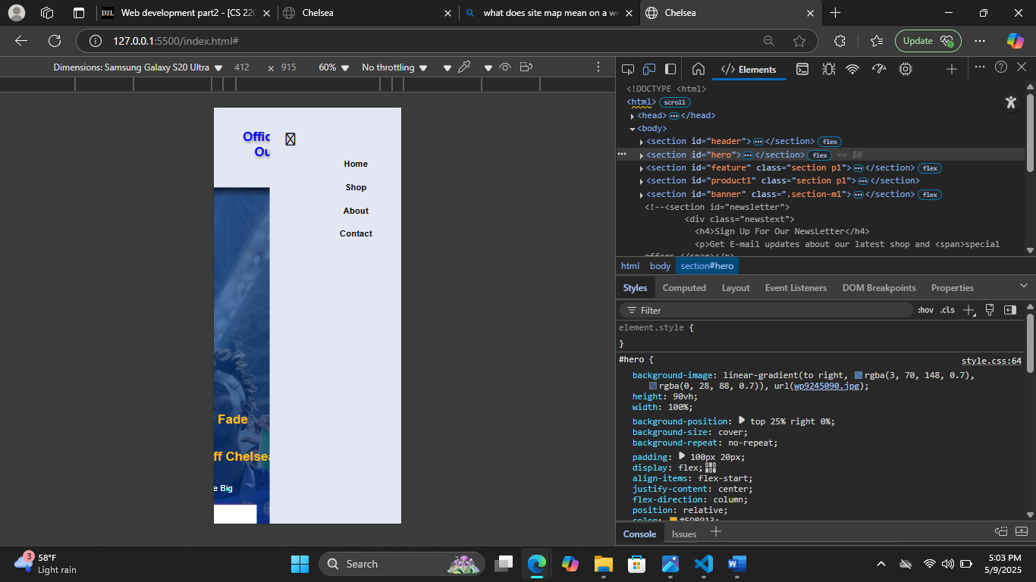
- Forms
- Forms: forms are used for subscribing to the newsletter as well as getting feedback from the user. If the user tries to post an empty form, then they will be prompted to put in the missing information.
- Interactive Features:

- Security measures
-client-side validation: the website does not host an input validation for password/login
- other security Steps:

- User feedback integration
-user feedback was stored in an api called formspree. The website did not use star ratings, however if it did, It would have been under the jerseys in the shop page. Getting feedback from the user would allow the programmer to see what was functioning or if there is any minor misspelling that the programmer might have not noticed. Addition, getting feedback may give the programmer ideas on what next could be added to the website in the future.

- Challenges
-some of the challenges faced while creating the website is knowing how the structure of the website would look, finding vintage jerseys, knowing how to wrap different html contents with buttons too, so whenever the button is clicked it will show the html contents that it was wrapped with. I also realized that creating a global css that could be used multiple times was helpful when creating different html page sections. And not having to create different id/classes and styling them. Finally the next challenge I had was moving the items added in the shop page to the shopping cart page.
8. Conclusion
- I successfully created an e-commerce website that displays jerseys, add and deleting them from the cart as well as getting feedback from the users. The only refinements that I would add to this website is to create a login page and add coupons to at the checkout section of the shopping cart.

